Department of Electrical Engineering
The Superior University, Lahore

Computer Programming

Experiment No.13
Implementation of Strings

Prepared for:
Eisha Nawaz
By:
Name: Tanseer Haider
ID: SU91-BSEEM-F25-02
Section: Electrical Engineering Fall 25
Semester: 2nd

Total Marks: ______10_________
Obtained Marks: ______________
Signature: __________________
Date: __________________

Experiment No.13
Implementation of Strings
(Rubrics)

Name: Tanseer Haider ID: SU91-BSEEM-F25-02

- PSYCHOMOTOR
Serial No. | Criteria | Allocated Marks | Unacceptable  0% | Poor  25% | Fair  50% | Good  75% | Excellent  100% | Total Obtained
1 | Syntax handling | 1 | 0 | 0.25 | 0.5 | 0.75 | 1
2 | Program Coding Skills | 2 | 0 | 0.5 | 1 | 1.5 | 2
3 | Accuracy in Output Results | 3 | 0 | 0.75 | 1.5 | 2.25 | 3
Sub-Total |  | 6 | Sub Total Marks Obtained in Psychomotor (P)

- AFFECTIVE
Serial No. | Criteria | Allocated Marks | Unacceptable  0% | Poor  25% | Fair  50% | Good  75% | Excellent  100% | Total Obtained
1 | Assigned Tasks | 2 | 0 | 0.5 | 1 | 1.5 | 2
2 | Lab Report | 2 | 0 | 0.5 | 1 | 1.5 | 2
Sub-Total |  | 4 | Sub Total Marks Obtained in Affective (A)

Instructor Name: | Eisha Nawaz____ | Total Marks (P+A): | ______________
Instructor Signature: | ______________ | Obtained Marks (P+A): | ______________

Contents of Lab 12
1 Objectives 4
2 Lab Tasks 9
2.1 Task 1 9
2.2 Task 2 9
3 Home Assignment: 9
3.1 Task 1 9
3.2 Task 2 9

Implementation of Strings

Objectives
- To have better knowledge about strings and how to use them Recursion in C++
Lab Description:
C++ provides following two types of string representations −
• The C-style character string.
• The string class type introduced with Standard C++.
The C-Style Character String
The C-style character string originated within the C language and continues to be supported
within C++. This string is actually a one-dimensional array of characters which is terminated
by a null character '\0'. Thus a null-terminated string contains the characters that comprise
the string followed by a null.
The following declaration and initialization create a string consisting of the word "Hello". To
hold the null character at the end of the array, the size of the character array containing the
string is one more than the number of characters in the word "Hello."
char greeting[6] = {'H', 'e', 'l', 'l', 'o', '\0'};
If you follow the rule of array initialization, then you can write the above statement as
follows −
char greeting[] = "Hello";
Following is the memory presentation of above defined string in C/C++ −
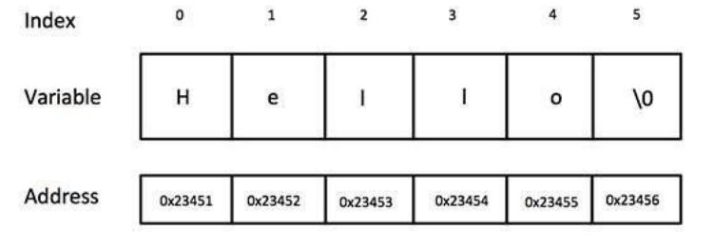
Actually, you do not place the null character at the end of a string constant. The C++
compiler automatically places the '\0' at the end of the string when it initializes the array.
Let us try to print above-mentioned string –
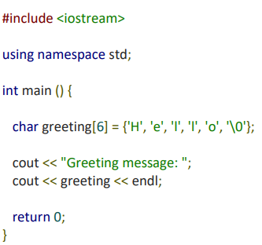
When the above code is compiled and executed, it produces the following result
Greeting message: Hello
C++ supports a wide range of functions that manipulate null-terminated strings
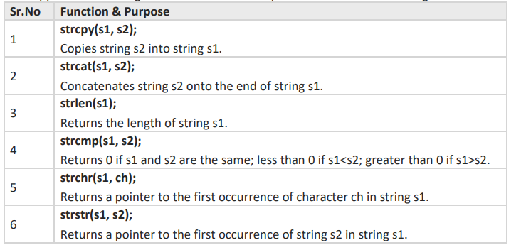
Following example makes use of few of the above-mentioned functions
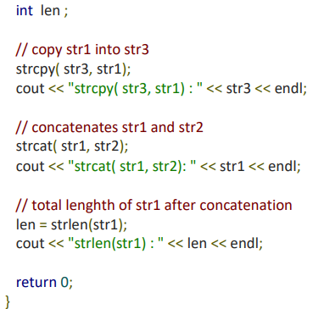
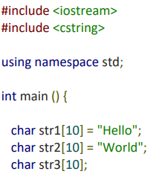

When the above code is compiled and executed, it produces result something as follows −
strcpy( str3, str1) : Hello
strcat( str1, str2): HelloWorld
strlen(str1) : 10
The String Class in C++
The standard C++ library provides a string class type that supports all the operations mentioned above, additionally much more functionality. Let us check the following example
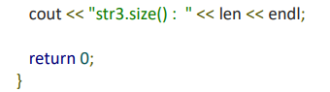
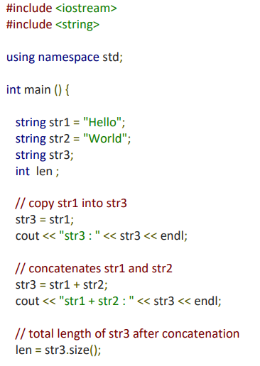

When the above code is compiled and executed, it produces result something as follows −
str3 : Hello
str1 + str2 : HelloWorld
str3.size() : 10
- Example 1: C++ String to Read a Word
C++ program to display a string entered by user.
#include <iostream>
using namespace std;

int main()
{
char str[100];

cout << "Enter a string: ";
cin >> str;
cout << "You entered: " << str << endl;

cout << "\nEnter another string: ";
cin >> str;
cout << "You entered: " << str << endl;

return 0;
}

Output
Enter a string: C++
You entered: C++

Enter another string: Programming is fun.
You entered: Programming

Notice that, in the second example, only "Programming" is displayed instead of "Programming is fun".
This is because the extraction operator >> works as scanf() in C and considers a space " " as a terminating character.
- Example 2: C++ String to read a line of text
C++ program to read and display an entire line entered by the user.
#include <iostream>
using namespace std;

int main()
{
char str[100];
cout << "Enter a string: ";
cin.get(str, 100);

cout << "You entered: " << str << endl;
return 0;
}
Output
Enter a string: Programming is fun.
You entered: Programming is fun.
To read the text containing blank space, cin.get function can be used. This function takes two arguments.
The first argument is the name of the string (address of the first element of the string), and the second argument is the maximum size of the array.
In the above program, str is the name of the string and 100 is the maximum size of the array.
- String Object
In C++, you can also create a string object for holding strings.
Unlike using char arrays, string objects have no fixed length and can be extended as per your requirement.
- Example 3: C++ string using string data type
#include <iostream>
using namespace std;

int main()
{
// Declaring a string object
string str;
cout << "Enter a string: ";
getline(cin, str);

cout << "You entered: " << str << endl;
return 0;
}
Output
Enter a string: Programming is fun.
You entered: Programming is fun.
In this program, a string str is declared. Then, the string is asked from the user.
Instead of using cin>> or cin.get() function, you can get the entered line of text using getline().
getline() function takes the input stream as the first parameter, which is cin and str as the location of the line to be stored.
- Passing String to a Function
Strings are passed to a function in a similar way arrays are passed to a function.
#include <iostream>

using namespace std;

void display(string);

int main()
{
string str1;
char str[100];

cout << "Enter a string: ";
getline(cin, str1);

cout << "Enter another string: ";
cin.get(str, 100, '\n');

display(str1);
display(str);
return 0;
}

void display(char s[])
{
cout << "Entered char array is: " << s << endl;
}

void display(string s)
{
cout << "Entered string is: " << s << endl;
}
Output
Enter a string: Programming is fun.
Enter another string: Really?
Entered string is: Programming is fun.
Entered char array is: Really?
In the above program, two strings are asked to enter. These are stored in str and str1 respectively, where str is a char array and str1 is a string object.
Then, we have two functions display() that outputs the string onto the string.
The only difference between the two functions is the parameter.
The first display() function takes the char array as a parameter, while the second takes the string as a parameter.

Lab Tasks

Lab Task — Circuit Component Label Processor
Scenario: A technician logs component labels and circuit notes as text while inspecting a control panel. You will build a small toolkit of string-processing functions to help clean up and analyze these logs.

(a) String Length Function
Write a function stringLength(string s) that returns the number of characters in s. Test it with the component label "R220CAP".
#include <iostream>
using namespace std;

// TODO: write int stringLength(string s)
// it should count characters and return the count

int main()
{
string label = "R220CAP";
// TODO: call stringLength(label) and print the result
return 0;
}
Expected Output
Length of "R220CAP": 7

(b) Backward String Function
Write a function reverseString(string s) that returns s written backward — useful when a technician needs to read a serial code in reverse to verify it. Test with "R220".
Expected Output
Reversed: 022R

(c) Word Counter Function
Write a function wordCount(string s) that returns how many words are in s. Test with the maintenance note "Check resistor and capacitor values".
Expected Output
Number of words: 5

(d) Sentence Capitalizer Function
Write a function capitalizeSentences(string s) that capitalizes the first letter of every sentence in s. Test with "voltage high. check fuse. replace now."
// TODO: write string capitalizeSentences(string s)
// capitalize the first letter of the string, and the first letter after every '.' followed by a space
Expected Output
Voltage high. Check fuse. Replace now.

(e) Function Overloading — char Array vs string
Write two overloaded functions named display() — one that takes a char array (for a short device ID) and one that takes a string object (for a longer description). Test with deviceId = "EE-101" (char array) and description = "Voltage regulator module" (string).
// TODO: void display(char s[])
// TODO: void display(string s)

int main()
{
char deviceId[] = "EE-101";
string description = "Voltage regulator module";
// TODO: call display(deviceId) and display(description)
return 0;
}
Expected Output
Entered char array is: EE-101
Entered string is: Voltage regulator module

